Anterior Choroidal Artery – Plexal point

The plexal point is the point at which the anterior choroidal artery enters into the lateral ventricle of the brain at the choroidal fissure. The choroidal fissure, in this sense, is the narrow cleft along the medial wall of the lateral ventricle, where the choroid plexus is attached at the margins. Not to be confused with the choroidal fissure of the eye.

On lateral angiograms, the plexal point is seen to be 18–26 mm from the origin of the anterior choroidal artery. It is an important angiographic landmark, characterized by a steep downward progression of a few millimeters, then a sharp posterior turn to mark the point of entry.

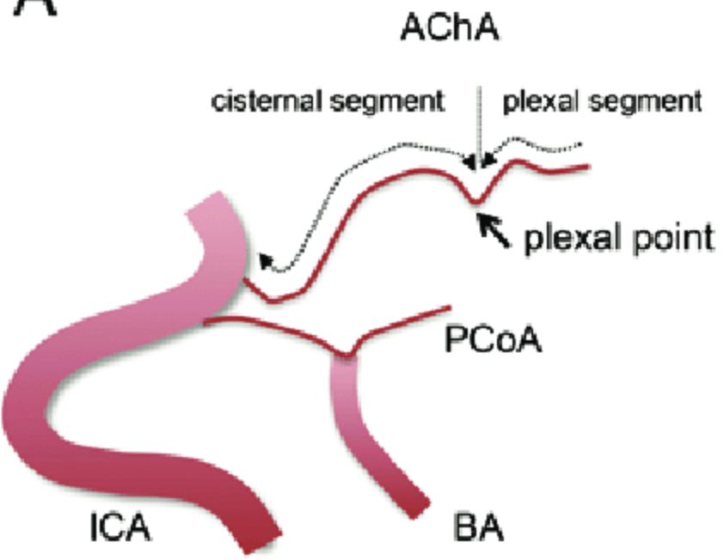
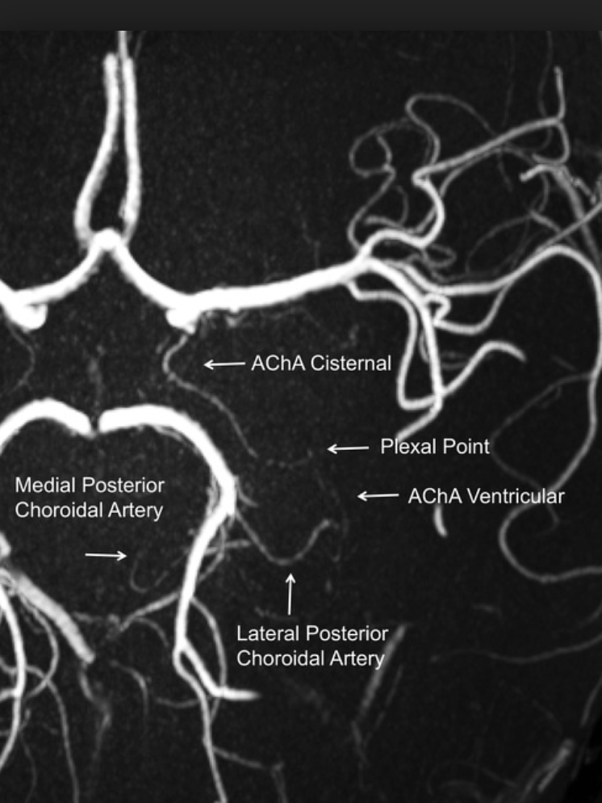

PCOM aneurysm clip can affect anterior choroidal artery, usually causing a motor deficit via infarct in the internal capsule.
- AChA supplies the parts of the brain important for vision and motor control (optic chiasm, hippocampus, posterior limb of internal capsule)
- Anterior choroidal artery syndrome (due to infarction of AChA) = triad of hemiplegia, hemianaesthesia, and contralateral hemianopia

ACOM clip can affect recurrent artery of Heubner, causing caudate infarct.
- = medial striate artery = largest perforating branch from the proximal ACA, the only one routinely seen on angiography
- Supplies the head of caudate and anterior limb of internal capsule, (also paraterminal gyrus, anterior portion of the lentiform nucleus)

Homunculus motor strip – standing on nuts medially, hand is at the 45 degree point on the convexity, essentially the same for the sensory.

Venous angle – the confluence of the thalamostriate veins and the septal veins, localize the foramen of Monro. Thalamostriate veins and septal veins both drain into the internal cerebral vein.
On angiography, the venous angle is “formed” by the thalamostriate vein and the internal cerebral vein.
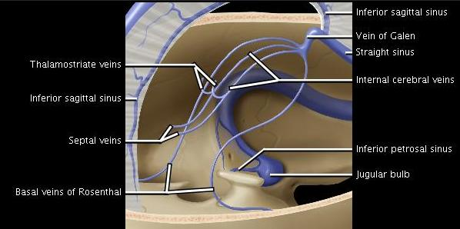

Cingulate sulcus – forms the marginal ramus, which is posterior to the paracentral lobule.
- Marginal sulcus (= pars marginalis) is the extension of the cingulate sulcus posterosuperiorly. This separates the paracentral lobule from the precuneus on the medial surface of the cerebral hemisphere. It is a great landmark for location of the central sulcus, which is located one sulcus anterior…
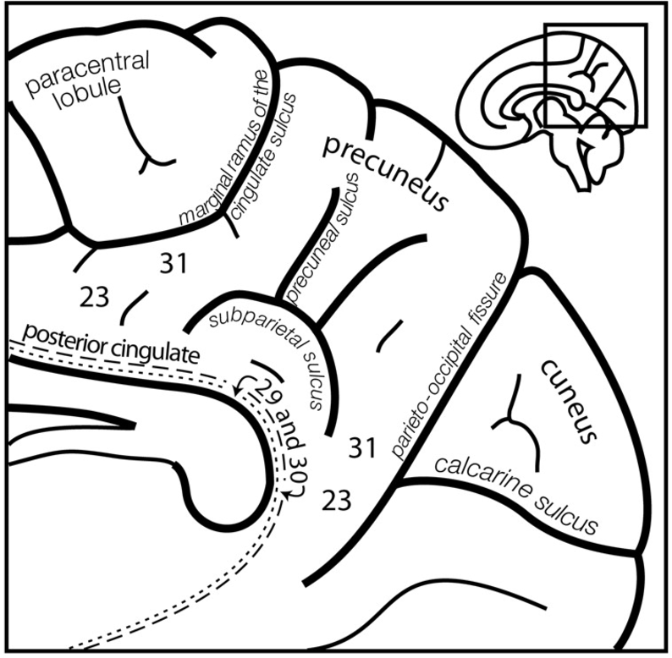

État criblé = status cribrosum, “sieve like” = multiple enlarged perivascular spaces (Virchow-Robin spaces) in the basal ganglia, usually symmetrical. Due to chronic HTN, which causes small vessel pulsations to burrows out holes in the white matter.
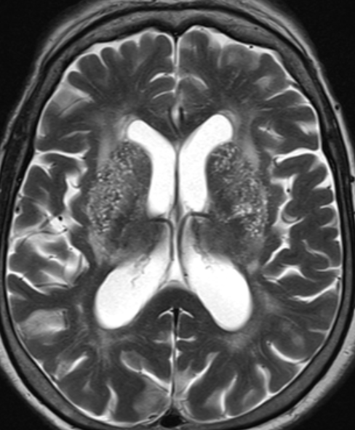
Versus État lacunaire = multiple lacunar infarcts
Vein of Labbe – venous infarct in anterior temporal lobe (leading to aphasia), anastomoses with the Vein of Trolard via the superficial middle cerebral vein (SMCV).
- Vein of Labbe is a superficial vein of the brain, and the largest channel that crosses the temporal lobe, btw the Sylvian fissure and the transverse sinus, and connects the SMCV and transverse sinus.
- Important in surgically planning of temporal lobectomy vein should be preserved

Trolard = Superior anastomotic vein
SMCV = Middle anastomotic vein = Sylvian vein
Labbe = Inferior anastomotic vein
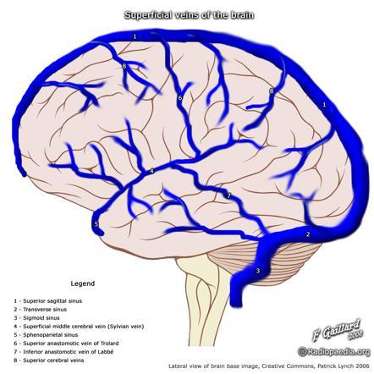
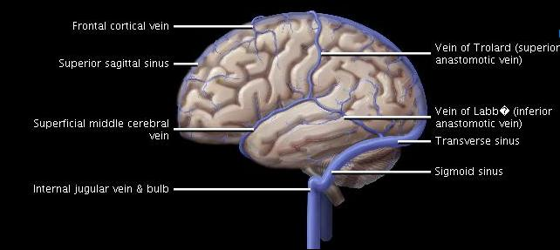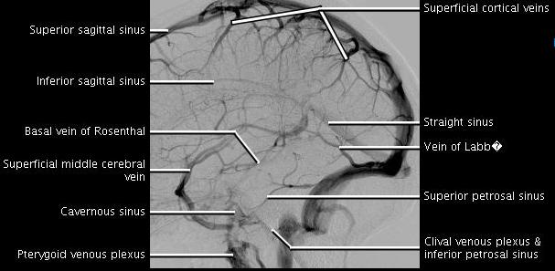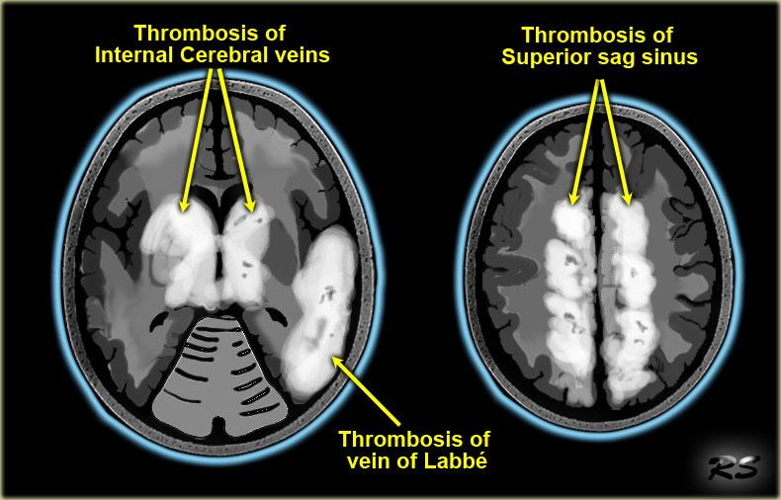
CSF volumes:
25cc ventricular volume
125cc of subarachnoid space for total neuraxis volume of 150cc.
500cc CSF production daily (20cc per hour), replenishes the total volume 3-4 times daily.

Laplace law – as pressure increases, regions with larger surface area (assuming similar compliance) are subject to more pressure and preferentially dilate.

Ex: one big balloon and one small balloon containing water, and connected by a straw with a stopcock; open the stopcock, the small balloon will shrink, water will flow into the big balloon.
Ex: Temporal horns enlarge first when lateral ventricles obstructed.

- Also, vents are hardest to re-open once they’re collapsed for that same reason. So if you overshunt a patient, the extra-axial fluid tends to accumulate before the vents re-expand (BAD!)

Choroid plexus distribution:

Note frontal and occipital horns of lateral vents don’t have any.

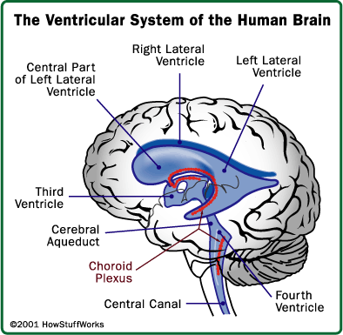

Types of vascular malformations:
- cavernous malformation (assoc with DVA in 30%) - developmental venous anomaly
- AVM
- capillary telangiectasia

When to image scoliosis
- pain
- curve > 20
- atypical curve
Typical curve is thoracic spine to the right and lumbar spine to the left (S-shape)
Atypical curve increase risk of intrathoracic pathology

Spine fracture morphology tips:
- Degenerative Listhesis: canal stenosis, DJD related, relative sparing of neural foramina
- Congenital or traumatic Listhesis with lysis: canal ok (pseudo widening), neural foramina narrowing

Note: Congenital hypoplastic posterior wall can simulate anterolisthesis, but it’s often a fake-out. However, it is associated with congenital spondylolysis, so there’s a baseline “posteriorly wedged” appearance, kind of like increasing the anterior subluxation tendency via the wedging morphology.
(AJNR April 2009 30: 674-680)

Compression fracture:
Asymmetric posterior wall involvement (+/- retropulsion) is more likely pathologic, as normal compression fractures cause anterior wedging.

Clava: gracile tubercle located at cervical medullary junction, just below the obex, which is the opening of the central canal of the cord.

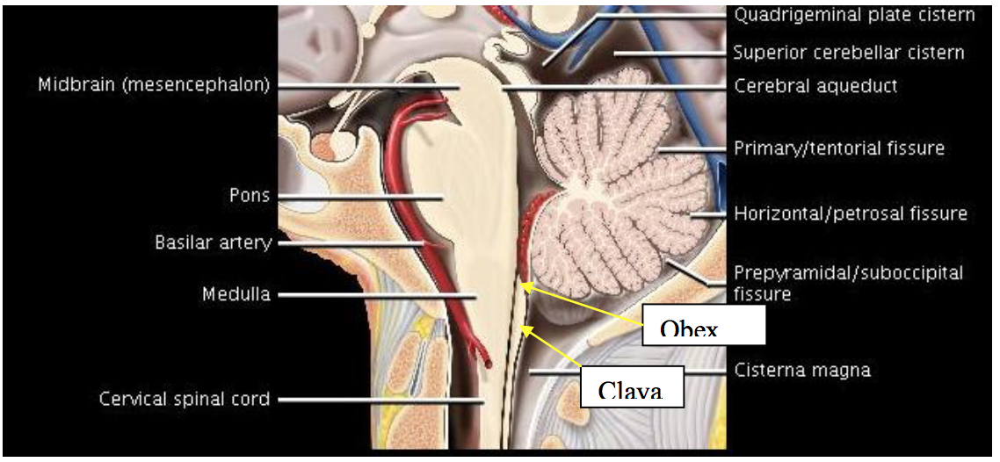

Borders of the third ventricle:
Lamina terminalis (anterior, which connects anterior commissure), fornix (roof), thalami (lateral)
4 recesses:
Optic recess, infundibular recess (anteriorly)
Suprapineal recess, pineal recess (posteriorly)
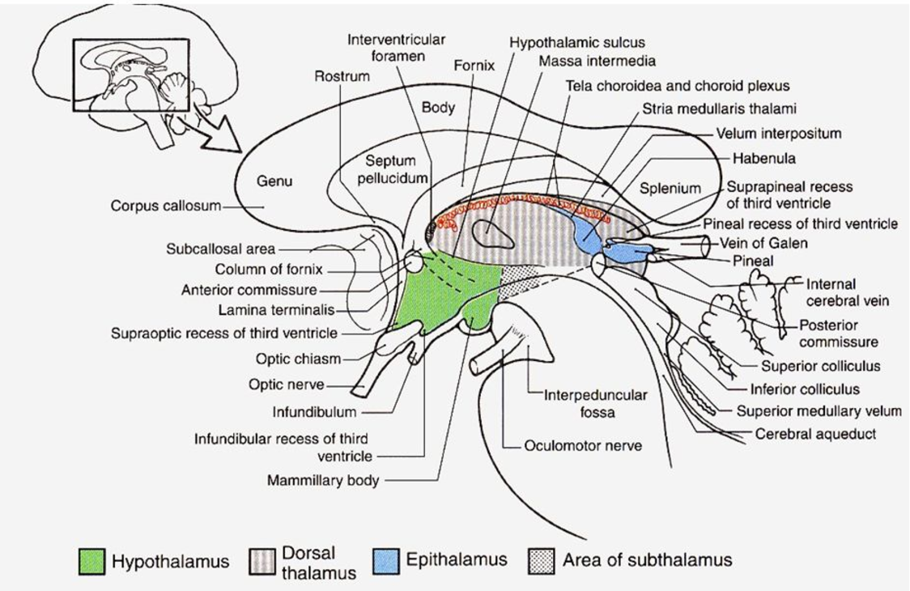

Basal Ganglia
Caudate, putamen, globus palladus, subthalamic nuclei.

Necks terms: longus capitis/colli, fossa of rosenmuller, Eustachian tube opening, aryepiglottic fold, tensor and levator veli palatini

Gradenigo Syndrome: petrous apicitis, which can lead to cavernous sinus thrombosis, 6th and possible 5th nerve palsy (via extension of inflammation to Dorello canal and Meckel’s cave).

Brain anatomy term:
- petroclival ligament: attachment of the tentorium centrally and medially.
- broca and wernicke, tegman tympani,
- 2 bones make up the Clivus

Membrane of Lillequist: arachnoid membrane arising from the dorsum sellae to the anterior edge of the mamillary body, and pons. The Liliequist membrane is also known to partially or completely obstruct CSF flow at the suprasellar cistern. It is also closely associated with the formation of the suprasellar arachnoid cyst. Pulsations in CSF and increased pressure below the obstructing membrane result in upward expansion of the membrane to form a cystic diverticulum.
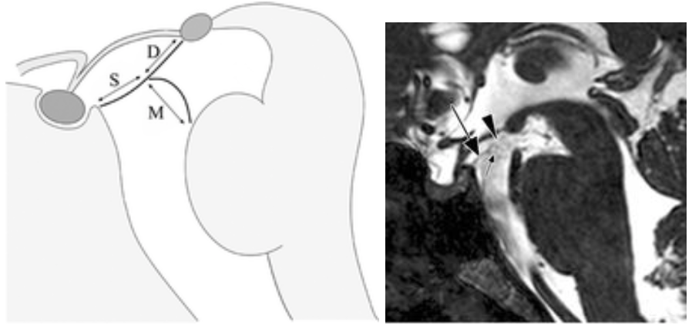

Cholesterol granuloma: petrous apex, bright on T1 (“chocolate cyst”, contains “old blood” – metHb), inhomogeneous T2 bright (metHb and hemosiderin).
- Sharply marginated, expansile PA lesion
- Trabecular breakdown with cortical thinning of PA expected
- Larger lesions will have areas of focal bony wall dehiscence

Vasogenic edema affects the white matter, loss of BBB (infection, tumor), EXTRACELLULAR FLUID.
Cytotoxic edema affects gray matter + white matter, hydropic dying cells (infarct), INTRACELLULAR FLUID.

Diseases to know: pseudotumor cerebri (idiopathic intracranial hypertension) and orbital mass differential.

Neuromyelitis optica (NMO), also known as Devic's disease or Devic's syndrome, is an autoimmune, inflammatory disorder in which a person's own immune system attacks the optic nerves and spinal cord. This produces an inflammation of the optic nerve (optic neuritis) and the spinal cord (myelitis). Although inflammation may also affect the brain, the lesions are different from those observed in the related condition, multiple sclerosis. Spinal cord lesions lead to varying degrees of weakness or paralysis in the legs or arms, loss of sensation (including blindness), and/or bladder and bowel dysfunction.

Devic's disease is a rare disorder which resembles multiple sclerosis (MS) in several ways, but requires a different course of treatment for optimal results. It has also been suggested to be a variant form of acute disseminated encephalomyelitis. The likely target of the autoimmune attack, at least in some patients with NMO, has been identified as a protein of the nervous system cells called aquaporin 4.

MELAS: Mitochondrial encephalomyopathy, lactic acidosis, and stroke-like episodes
– is one of the family of mitochondrial cytopathies, which also include MERRF, and Leber's hereditary optic neuropathy. Most affected individuals experience stroke-like episodes beginning before age 40.

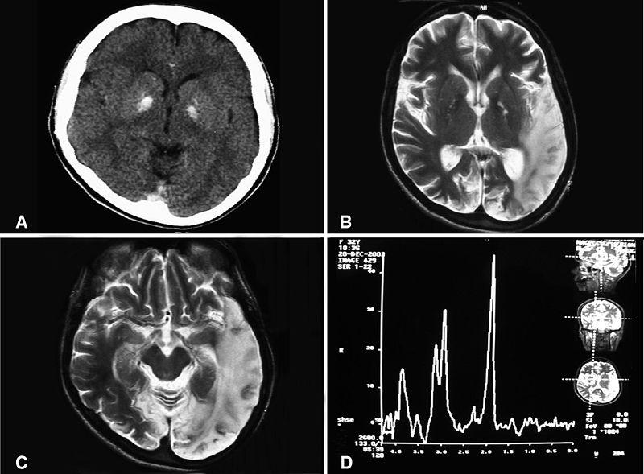
Note: increased lactate peak in the Spec.

Tolosa Hunt (inflammatory orbital pseudotumor which involves cavernous sinus):
- Nonspecific orbital inflammation, not due to any known etiology or systemic illness
- Pain & swelling, restricted eye motion, diplopia, proptosis, & impaired vision – Treat with Steroids
- Orbital pseudotumor can involve several areas, categorized by area(s) of involvement
- Myositic (extraocular muscles [EOM])
- Lacrimal (lacrimal gland)
- Anterior (globe, retrobulbar orbit)
- Diffuse (multifocal intraconal ± extraconal)
- Apical (orbital apex, intracranial extension)
- Tolosa Hunt (cavernous sinus)

Medial Lenticulostriate arise from ACA (A1 or Acomm)

Recurrent artery of Heubner arises from distal A1

Lateral Lenticulostriate off MCA (M1)

Thalamoperforators off PCA (P1) !!! (variant large perforator = artery of Percheron)

Anterior choroidal artery is the last branch of ICA

First intradural portion of the ICA is the supraclinoid (not the cavernous, as that’s technically a dural reflection)

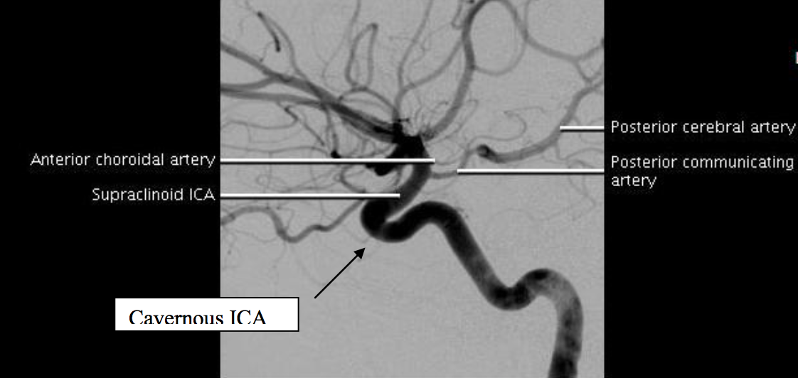

Condylar fracture takes out the hypoglossal canal. Know the 3 types of condylar fractures. Type 3 is most often unstable, with ligament disruption.

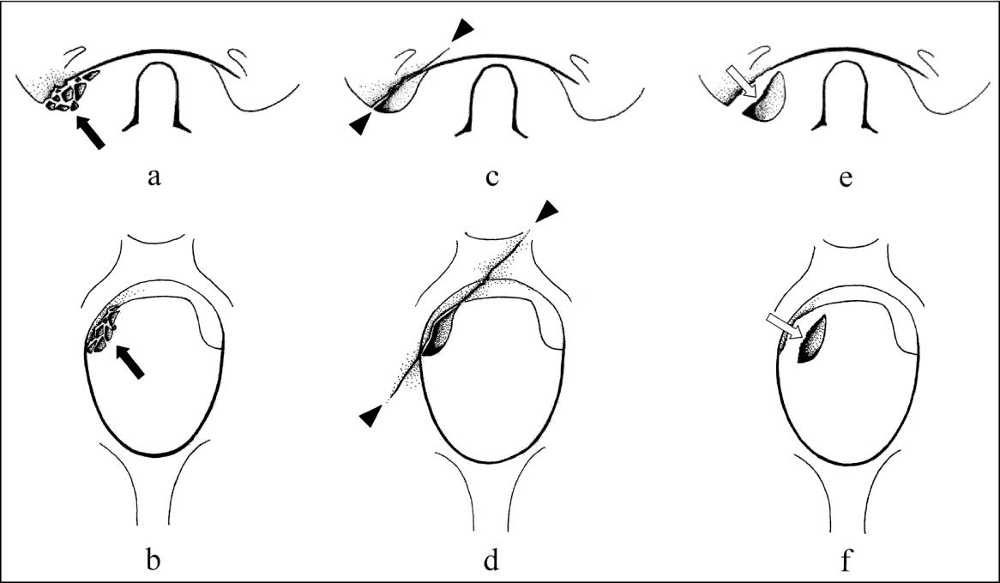

Anderson & Montesano classification (1988)
- Type I: Least common
  - Axial load injury with component of ipsilateral flexion; an impaction fracture. Causes comminuted condylar fracture without displacement
- Type II
  - Basilar skull fracture extending into occipital condyle(s), usually from direct blow to skull. Intact tectorial membrane & alar ligaments preserve stability
- Type III: Most common (75%)
  - Avulsion fracture of inferomedial condyle, usually result of severe contralateral flexion & rotation
  - ± medially displaced fragment & partial or complete disruption of tectorial membrane & contralateral alar ligament
  - Inferior clivus may also be involved

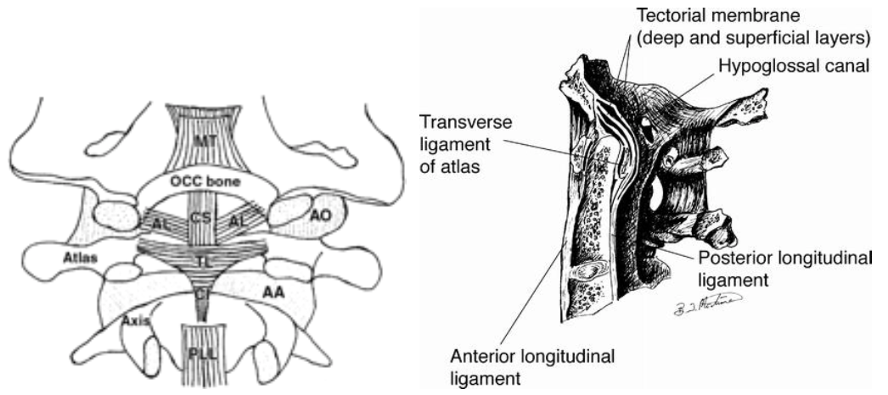

Tectorial membrane is the natural continuation of the PLL, and is the most important stabilizing ligament of the craniocervical junction.

Recurrent artery of Huebner = prominent medial lenticulostriate branch from A1 or proximal A2 supplying caudate head, anterior aspect of lentiform nucleus, and anterior limb of internal capsule.

Artery of Percheron – (anatomic variant) a single large perforating artery from P1 supplies both Thalami and medial midbrain. Vs. most thalamic perfusion comes from the small thalamoperforators of the PCA.
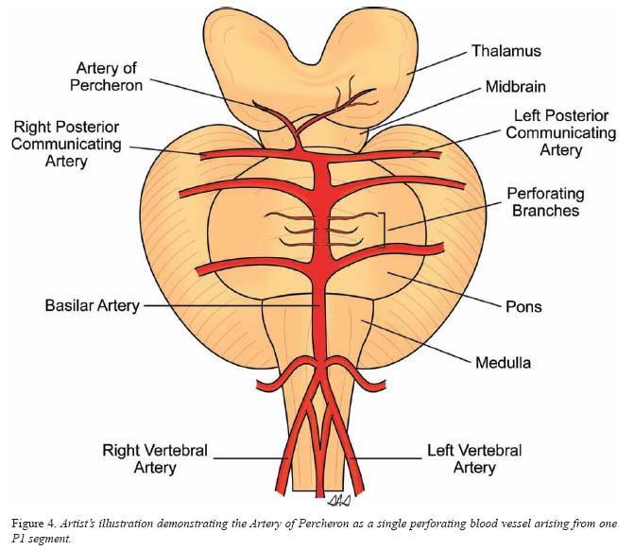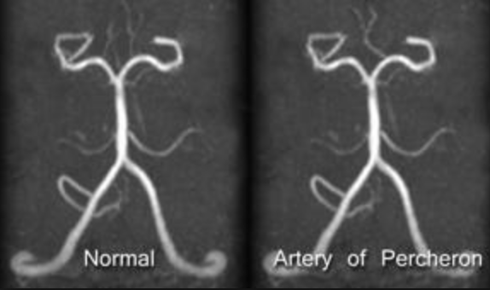

Parinaud’s syndrome = dorsal midbrain syndrome, is a supranuclear vertical gaze disturbance caused by compression of the tectal plate. It is the most common presentation of a pineal tumor, but can also come from posterior commissure resection, due to proximity to pineal gland. Parinaud’s syndrome is a group of abnormalities of eye movement and pupil dysfunction. It is caused by lesions of the upper brain stem and is named for Henri Parinaud. Parinaud's Syndrome results from injury, either direct or compressive, to the dorsal midbrain. Specifically, compression or ischemic damage of the mesencephalic tectum, including the superior colliculus, adjacent oculomotor (origin of cranial nerve III) and Edinger-Westphal nuclei, causing dysfunction to the motor function of the eye.
- Upward gaze palsy, often manifesting as diplopia
- Pupillary light-near dissociation (pseudo argyll robertson pupil -- pupils respond to near stimuli, but not light)
- Convergence-retraction nystagmus
Pineal gland is attached to the posterior commissure and habenular commissure, keeps it from floating away.

Radiation can induce cavernomas / radiation-induced hemorrhagic vasculopathy, tiny punctate foci of susceptibility.

Anastomotic loop of lisorthis?? Basket around the conus, communication of anterior and posterior spinal arteries. == Arterial basket of the conus medullaris.

CN 9 enters the skull at the pars nervosa, little cleft above the hypoglossal canal.

Superior Jugular Bulb/Jugular foramen
- The smaller, anteromedial, "pars nervosa" compartment contains CN 9, Jacobson nerve (or the tympanic nerve, a branch of CN 9), and receives the venous return from inferior petrosal sinus.
- The larger, posterolateral, "pars vascularis" compartment contains CN 10, CN 11, Arnold's nerve (or the auricular branch of CN 10 involved in the Arnold's reflex, where external auditory meatus stimulation causes cough), jugular bulb, and posterior meningeal branch of ascending pharyngeal artery.
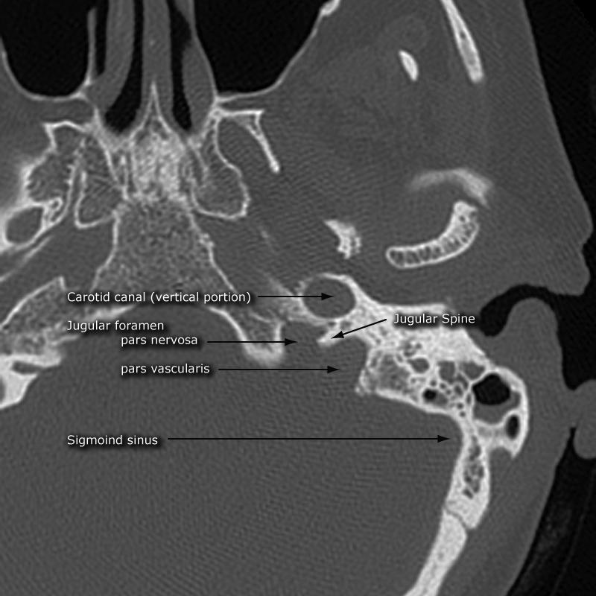

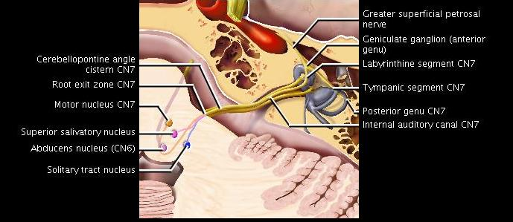

FACIAL NERVE SEGMENTS – IAC-LG(Branch)TM

IAC segment intracranial CN7
- Extent: Porus acusticus to IAC fundus
- Relationship: Anterosuperior position above crista falciformis
- Branches: None

Labyrinthine segment intratemporal CN7
- Extent: Connects fundal CN7 to geniculate ganglion
- Relationship: Passes through bony labyrinth just superior to cochlea
- Branches: None

Geniculate ganglion (anterior genu) – has a venous plexus on it, so it always enhances in this portion
- Extent: Single site anterosuperior to cochlea
- Branches: Greater superficial petrosal nerve

Tympanic segment intratemporal CN7 (horizontal segment)
- Extent: Connects anterior to posterior genu
- Relationship: Passes immediately under lateral semicircular canal
- Branches: None

Posterior genu
- Extent: Elbow of CN7 turning tympanic segment into mastoid segment

Mastoid segment intratemporal CN7 – SHOOTS DOWN AND OUT SM FORAMEN
- Extent: Connects posterior genu to stylomastoid foramen
- Relationship: Passes inferiorly in bone just posterior to facial nerve recess

Andersson lesion –
Ankylosing spondylosis. An inflammatory involvement of the intervertebral discs.
MRI: disc-related signal abnl of one or both vertebral halves, only hemispherically shaped
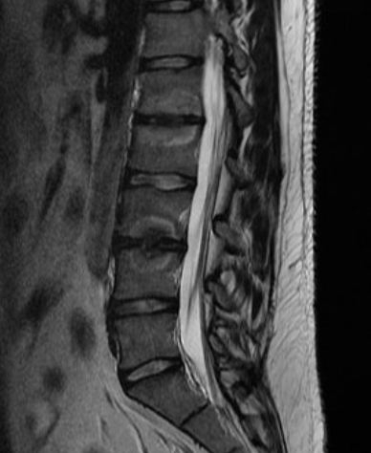

Uncinate fasciculus = white matter tract connecting the frontal and temporal lobes
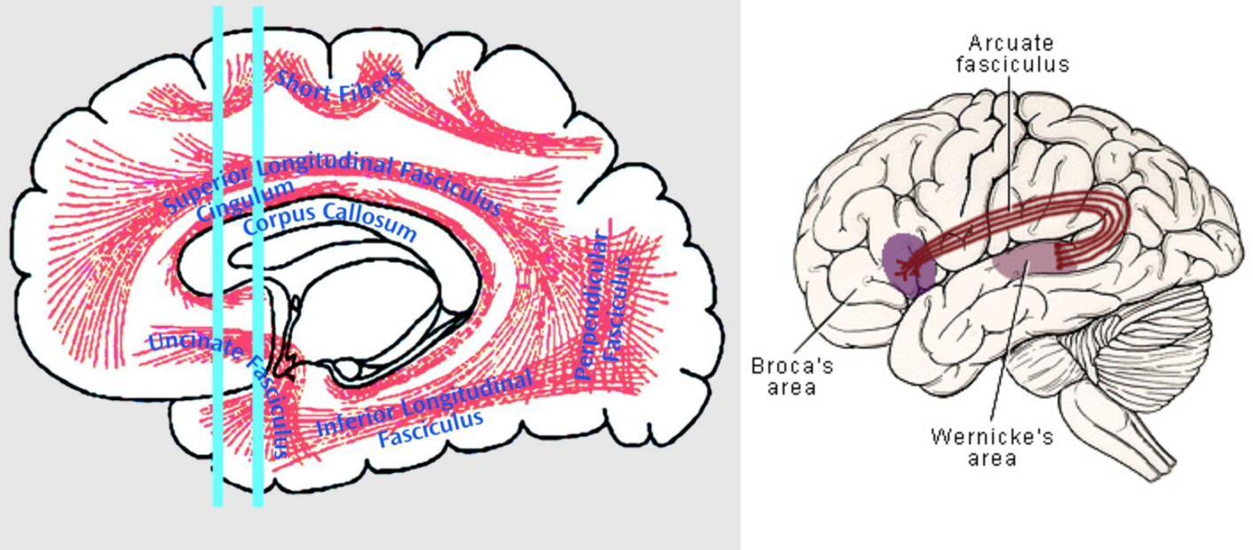
Superior longituidinal fasciculus = connects the frontal, occipital, parietal, and temporal lobes
Arcuate (perpendicular) fasciculus = connects gyri in frontal and temporal lobes
Inferior longitudinal fasciculus = connects occipital to temporal pole
Cingulum = connects frontal & parietal lobes to the parahippocampal gyrus and adjacent temporal gyri

Artery of Adamkewicz is the largest anterior segmental medullary artery, at ~T10, feeds the anterior spinal artery. Takes a classic hairpin turn.

T-bone:

Singular Foramen -
a foramen in the internal acoustic meatus, posterior to the cochlear area, which transmits the nerves to the ampulla of the posterior semicircular duct. Transmits a branch of the inferior vestibular nerve.

Bill’s bar
Bony structure which separates CN7 and the superior vestibular nerve.

Crista Falciformis
Bony structure which separates CN7+Superior from CN8 and the Inferior.

Nerves in IAC
Anterior: CN7 above Cochlear nerve (“7-up / coke down”)
Posterior: Superior above inferior vestibular nerve.

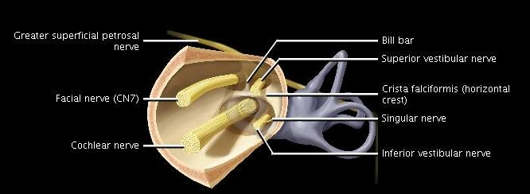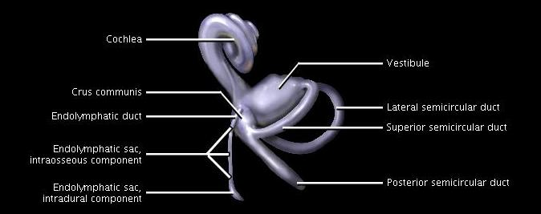

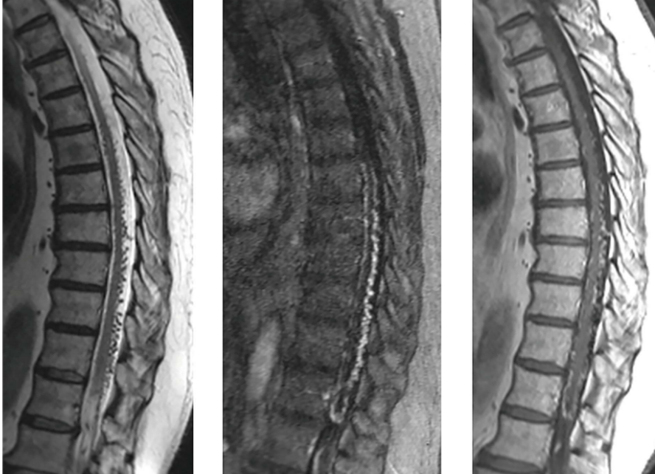
Dural AV fistula. Note the innumerable T2 flow voids seen primarily along the dorsal surface of the spinal cord. Foix-Alajouanine syndrome, is myelopathy secondary to venous congestion, because of congestive ischemia in the cord resulting from venous hypertension arising from reflux into the perimedullary veins.

Completely Ridiculous Trivia

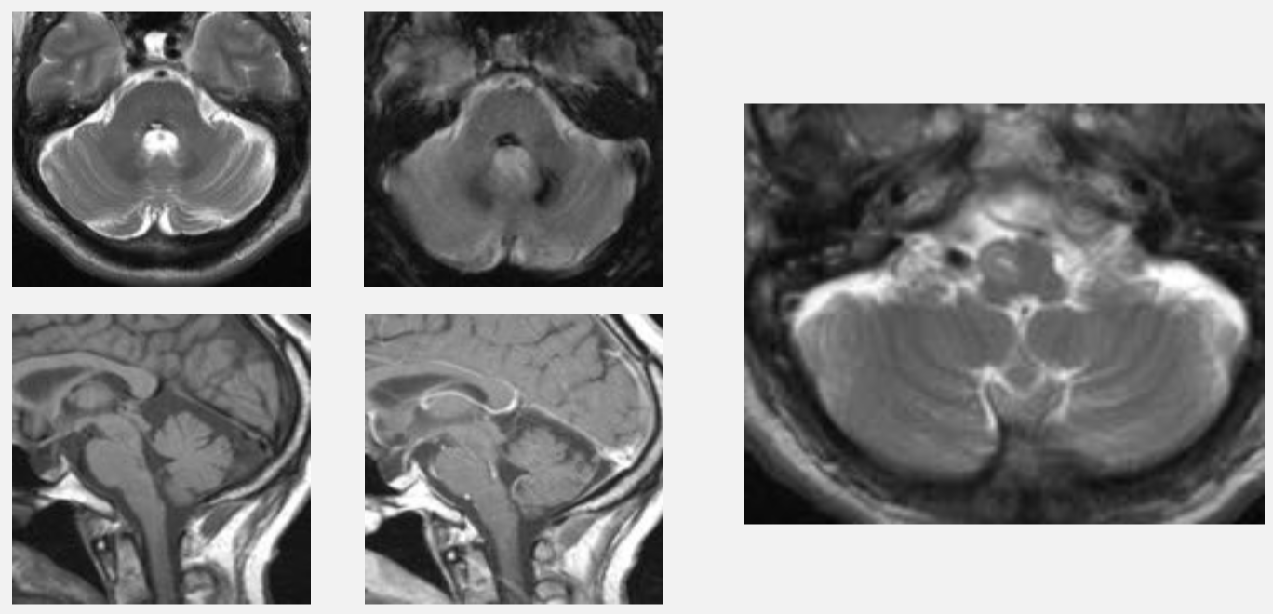
Hypertrophic olivary degeneration - causes palatal tremors/myoclonus. Secondary degeneration of inferior olivary nucleus (ION), usually caused by primary lesions in dento-rubro-olivary pathway (anatomical triangle of Guillain and Mollaret)

Symptomatic palatal tremor/myoclonus: Rhythmic involuntary movement of soft palate, uvula, pharynx, and larynx

